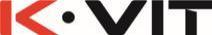 | PRODUCT SPECIFICATION
SHO310KBL - Kolt Shower with Sliding Handset and Drench Head Black
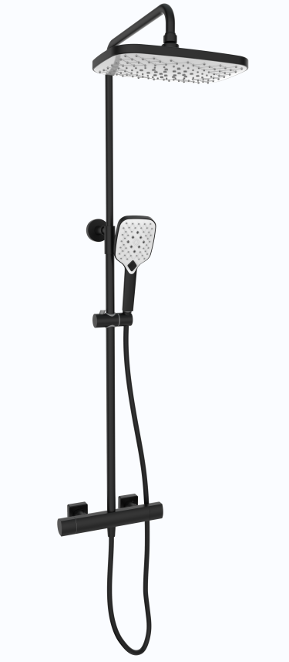 |  | BAR CODE: 5055681461324  COLOUR: MATT-BLACK  WEIGHT:  NET 4.34kg  GROSS 5.45kg  STANDARDS: BS EN 1111 NOTES: SUITABLE FOR PRESSURES BETWEEN 0.2 - 5 BAR HOT & COLD PRESSURES MUST BE BALANCED SUITABLE FOR COMBI- BOILERS, UNVENTED MAINS PRESSURE SYSTEMS AND GRAVITY FED SYSTEMS SUITABLE FOR SHOWER PUMPS ANTI SCALD (THERMO STOP SET AT 38ᵒC) OVER HEAD SS DRENCHER/MULTI- FUNCTION HAND SET Flow Rate:
0 . 2 bar | 0 . 5 bar | 1 bar | 2 bar | 3 bar | 5 bar
4.6 L | 7.3 L | 10.3 L | 15.1 L | 17.7 L | 22.9 L
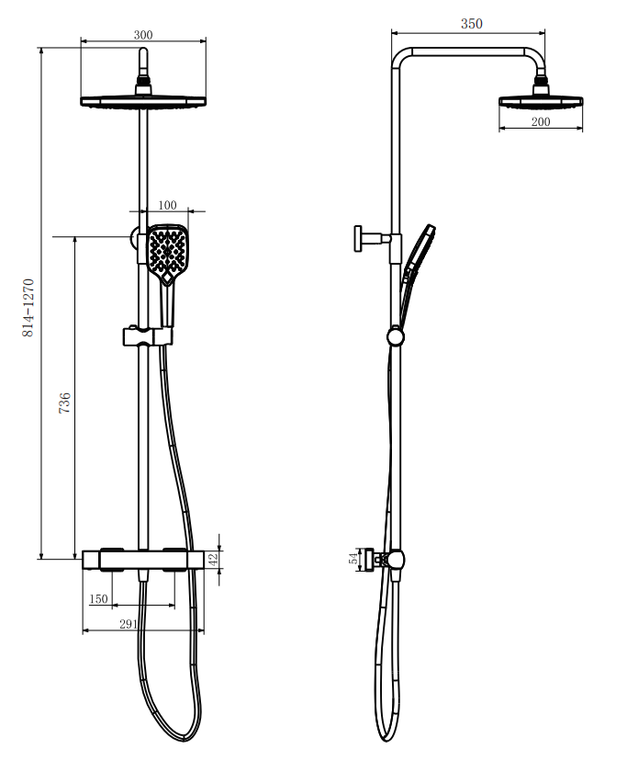
BOX SIZE 843X355X118

