 | PRODUCT SPECIFICATION
TAP300KCP-Kolt Mono Basin Mixer Chrome
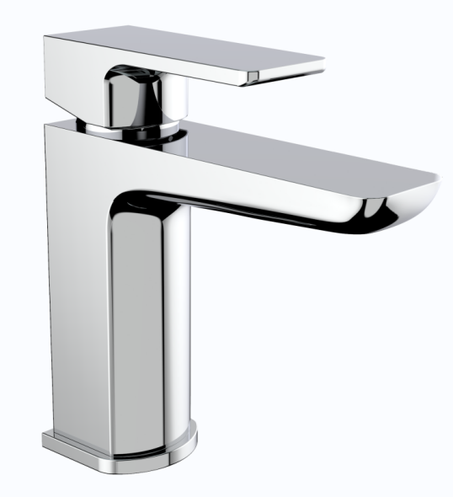 |  | BAR CODE: 5055681461195  COLOUR: CHROME  WEIGHT:  NET 1.18 kg (tap only)  GROSS 1.62 kg  0 . 2 bar 0 . 5 bar 1 bar 2 bar 3 bar  4.4 L 8.2 L 11.8 L 17.1L 20.8 L  STANDARDS: BS EN 200 NOTES: SUITABLE FOR PRESSURES BETWEEN 0.5-10BAR Flow Rate:
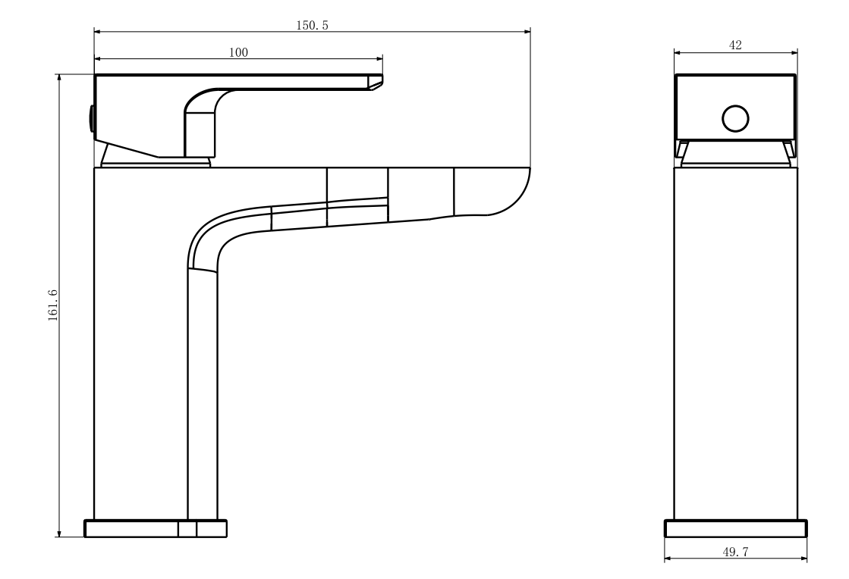
BOX SIZE 175X159X77

