 | PRODUCT SPECIFICATION
TAP301KCP-Kolt Hi-Rise Mono Basin Mixer Chrome
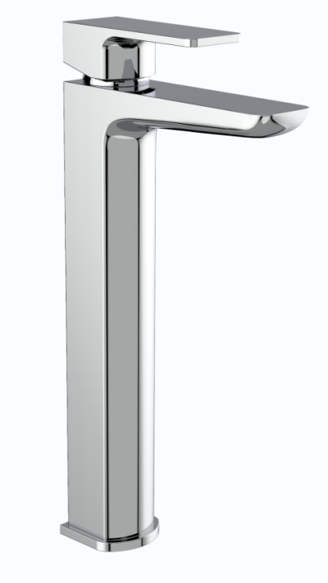 |  | BAR CODE: 5055681461201  COLOUR: CHROME  WEIGHT:  NET 1.57 kg (tap only)  GROSS 1.91 kg  0 . 2 bar 0 . 5 bar 1 bar 2 bar 3 bar  4.4 L 7.8L 11.4 L 16.4L 20.1 L  STANDARDS: BS EN 200 NOTES: SUITABLE FOR PRESSURES BETWEEN 0.5-10BAR Flow Rate:
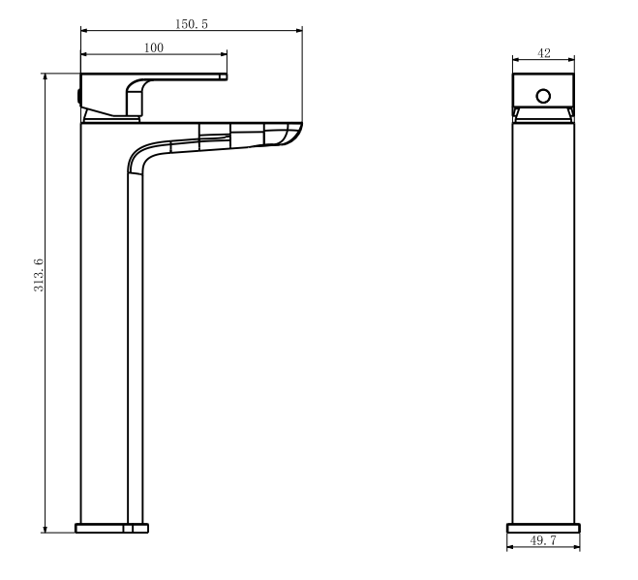
BOX SIZE 351X148X60

